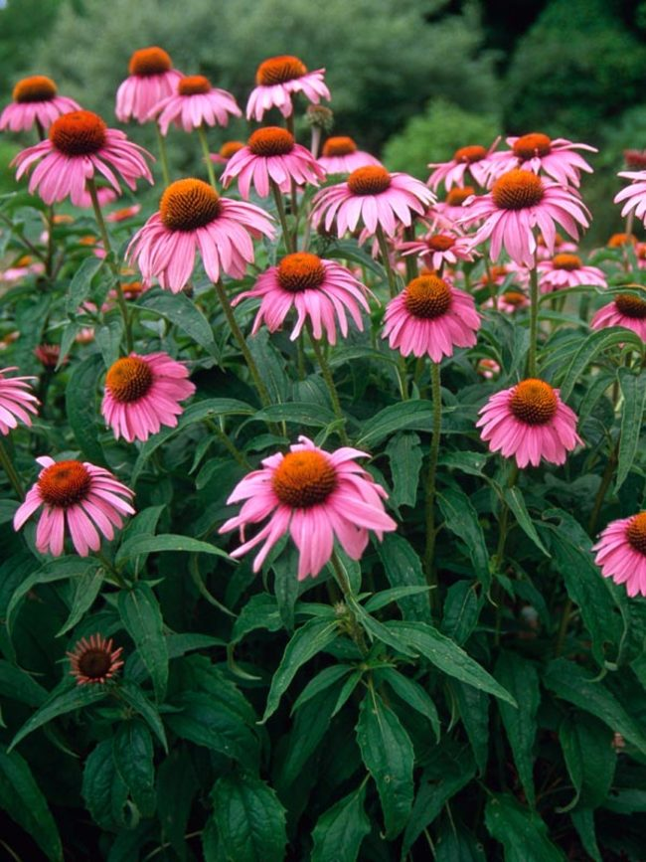
Purple Coneflower
Echinacea purpurea

*Sun to part-shade
*2ft-4ft tall *Drought tolerant once established *Deer/Rabbit resistant *Potent medicinal *Feeds pollinators and songbirds

